1. Go to Personnel system>>Personnel recruitment>>personnel details

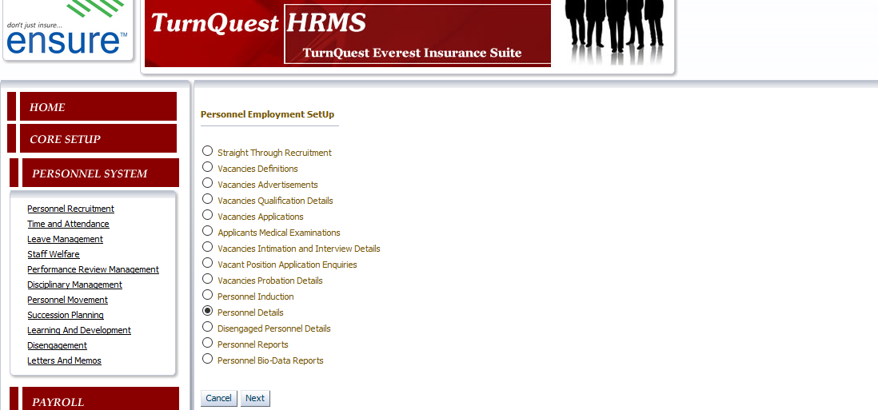

1. Select a personnel & tag the coverage area.

